**C# Poker Testing Document (STD)**

**Automatic solution application testing** – When there is a difference between buyins, and buyouts of the string received in the main function.

## Losers Gain Error

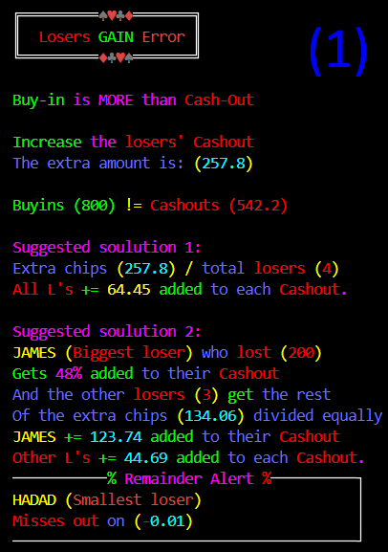

This pic belongs to test case (2, 7)

RecordStatsString("idan 50 213.5, hadar 250 199.2, James 200, Giora 200 35.75, hadad 100 93.75 ", playerStatsDic);

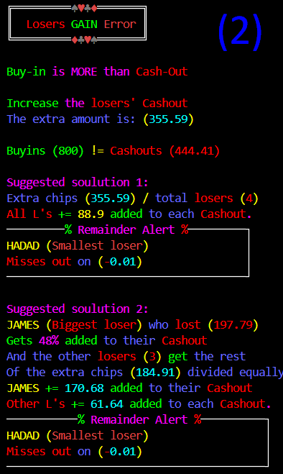

This pic belongs to test case (4)

RecordStatsString("idan 50 113.5, hadar 250 199.2, James 200 2.21, Giora 200 35.75, hadad 100 93.75", playerStatsDic);

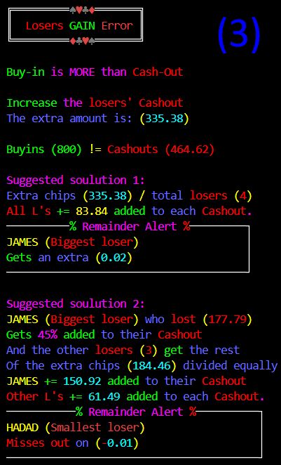

This pic belongs to test case (3)

RecordStatsString("idan 50 113.5, hadar 250 199.42, James 200 22.21, giora 200 35.75, hadad 100 93.74 ", playerStatsDic);

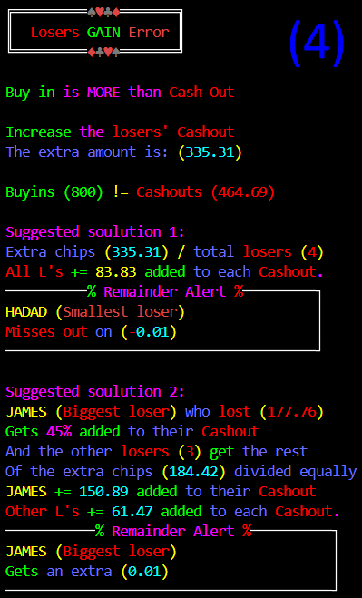

This pic belongs to test case (6)

RecordStatsString("idan 50 113.54, hadar 250 199.42, James 200 22.24, Giora 200 35.75, hadad 100 93.74 ", playerStatsDic);

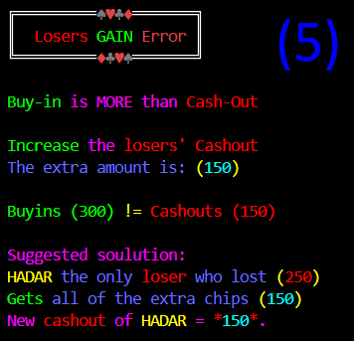

This pic belongs to test case (1)

RecordStatsString("idan 50 150, hadar 250 0 ", playerStatsDic);

**Solo loser**

1. **Test solution (only 1)**: OK [Picture (5)]

**Many losers**

1. **Test solution 1 (NO remainder)**: OK [Picture (1)]
2. **Test solution 1 (positive remainder)**: OK [Picture (3)]
3. **Test solution 1 (negative remainder)**: OK [Picture (2)]
4. **Test solution 2 (NO remainder)**:
5. **Test solution 2 (positive remainder)**: OK [Picture (4)]
6. **Test solution 2 (negative remainder)**: OK [Picture (1)]

## Winners Lose Error

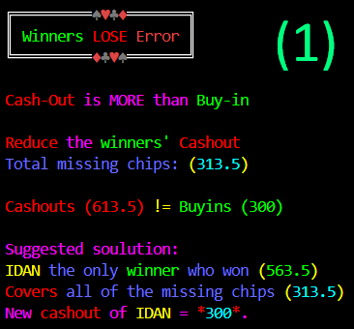

This pic belongs to test case (1)

RecordStatsString("idan 50 613.5, hadar 250 0 ", playerStatsDic);

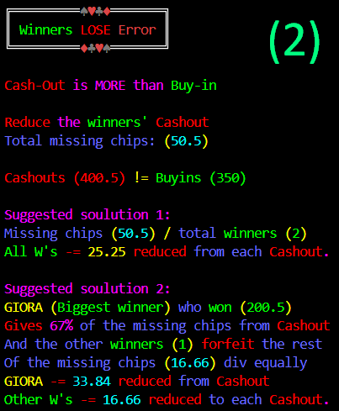

This pic belongs to test case (2, 5)

RecordStatsString("idan 50 150,gio 50 250.5 ,hadar 250 0 ", playerStatsDic);

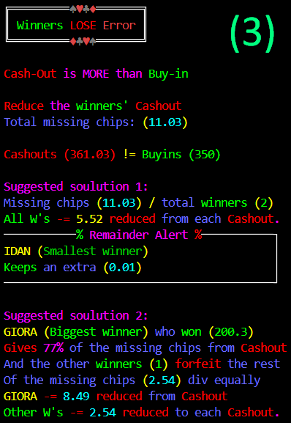

This pic belongs to test case (3)

RecordStatsString("idan 50 110.23,gio 50 250.30 ,hadar 250 0.5 ", playerStatsDic);

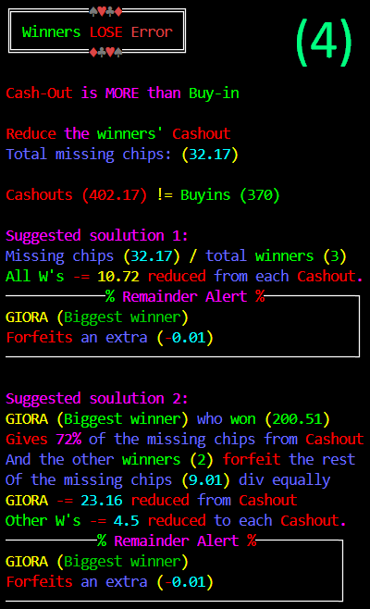

This pic belongs to test case (4,7)

RecordStatsString("idan 50 111,gio 50 250.51, Jameson 20 40.16 ,hadar 250 0.5 ", playerStatsDic);

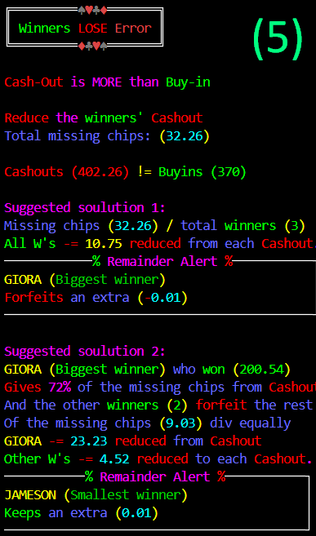

This pic belongs to test case (6)

RecordStatsString("idan 50 111,gio 50 250.54, Jameson 20 40.22 ,hadar 250 0.5 ", playerStatsDic);

**Solo winner**

1. **Test solution (only 1)**: OK [Picture (1)]

**Many winners**

1. **Test solution 1 (NO remainder)**: OK [Picture (2)]
2. **Test solution 1 (positive remainder)**: OK [Picture (3)]
3. **Test solution 1 (negative remainder)**: OK [Picture (4)]
4. **Test solution 2 (NO remainder)**: OK [Picture (2)]
5. **Test solution 2 (positive remainder)**: OK [Picture (5)]
6. **Test solution 2 (negative remainder)**: OK [Picture (4)]